**Online Hospital Appointment Application**

**Team Name:** Boycott

**Team Members:**

1. G Srihari
2. K Darshan Raj Kumar
3. K Prem Kumar
4. GVP Varun
5. B Lokesh

**Scrum Master:** G Srihari

# Product Owner: Venkatesh M

**Use Case Description:**

Healthcare providers can also harness the power of Hospital 24X7 as the definitive platform that helps them build their presence, grow establishments and engage patients more deeply than ever.

At a high level and with the initial Phase I release, this application will:

• Allow patients to register themselves to book appointments online.

• Allow doctors to register themselves to accept online appointments and attend patients.

• Allow receptionist to review and approve the booked appointment.

• Allow patients to update profile for themselves.

• Allow doctors to update profile for themselves.

• Allow patients to provide feedback on each doctor visit.

**Online Hospital Appointment application will include the following process:**

**Signup:** Patient and doctor register and create profile for booking appointments /handling appointments.

**Update Profile:** Patient/Doctor should update profile on first login.

**Book Appointments:** Patient can login and book multiple appointments (for more than one member in the family) limiting to only one appointment at a time.

**Approval:** Receptionist will check all the appointments and either approve or reject appointments based on doctor availability.

**Attend Patient:** Once appointment is approved, appointment is routed to doctor. Doctor will be able to attend patients based on slots.

**Feedback from Patient:** Once appointment case is resolved, Patient will get a feedback form on his recent doctor visit

# ECS LAYER

**Application Structure:** Hospital Appointment

**Application Name:** Hospital

**Organization Name:** KLH

**Division Name:** Div.

**Unit Name:** Unit

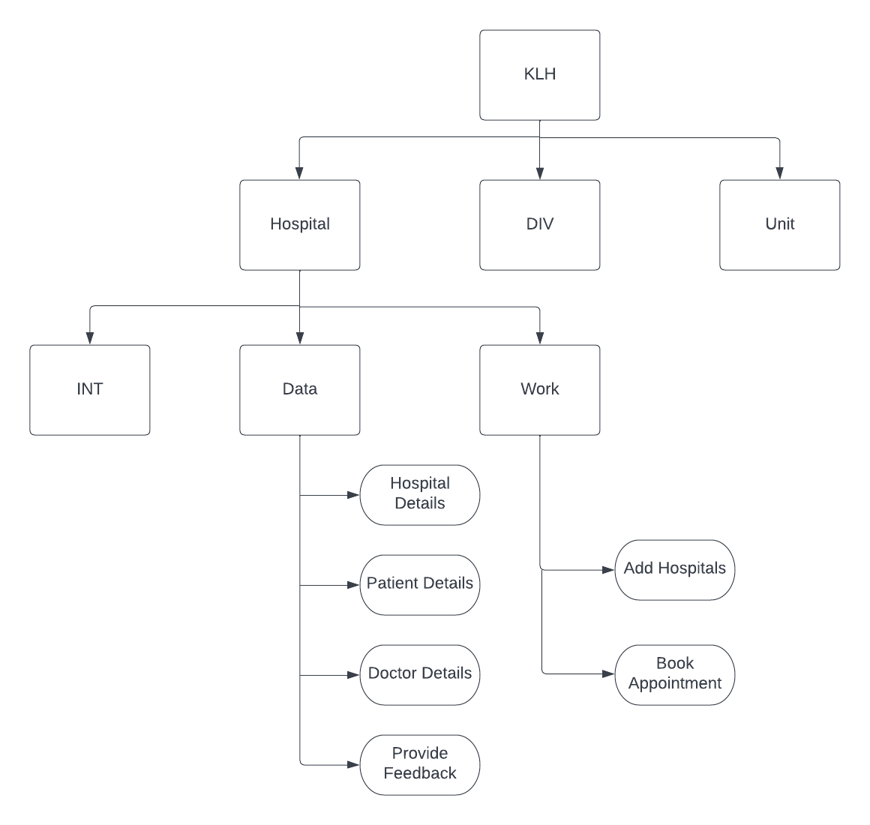

## Process Diagram

